STRATEGY GUIDE
When to reuse WineReg — and when not to

What this pack is
A Codecademy-style regularization lab on the UCI red-wine table: scale, split, unregularized LR, default L2, coarse then fine C, hold-out check, L1 as a feature screen. Extended with alternates, four practice drills, a knob-driven simulation, a reusable template, and audience-aware write-ups.

When this pattern is a good fit
- Binary flag, numeric (or already encoded) predictors, n in the hundreds to tens of thousands.
- You need to show a learner why C = 1 is not “regularization done.”
- You want one method that both shrinks (L2) and deletes (L1).
- The client will accept a probability + threshold, not a 1–10 score.
- A lab / sensor / scorecard team can actually drop a column after L1 zeros it.

When it is the wrong tool
- Rare events with fewer than ~10 events per free weight — switch to firth / stronger priors / fewer tests.
- The real target is the 1–10 rating. Use ordinal regression or a two-cut model.
- Price, vintage prestige, or critic score. Those have different confounders.
- Causal “raise sulphates, raise quality.” This is a classifier, not a dosing trial.
- A table that is already 200 dummies. Start with a filter or an embedded L1, not a 100-point C grid on the full card.

Recommended build order
- Draw the flowchart (load → scale → split → unreg → default L2 → coarse C → GridSearchCV → hold-out → L1 zeros).
- Reproduce Tasks 1–17 against WineReg_Solution.ipynb so the numbers match.
- Add one alternate (Pipeline or C=inf) so the lesson spelling is not the only spelling.
- Add the threshold table — that is the piece a GM can act on.
- Run the simulation with FLIP_P = 0.10 and N_JUNK = 5 to see L1 start deleting noise.
- Rewrite the four audience paragraphs; delete the wine metaphors if the next domain is banking.

C-window heuristic
Start with the lesson’s five-point grid. If train and test F1 are still flat at C = 1 and C = 0.1, drop a decade (10⁻⁴–10⁻²) and run GridSearchCV there. If both curves are still climbing at C = 1, the card wants less penalty, not more — expand upward. Never copy the wine window into a new domain without redrawing the plot.
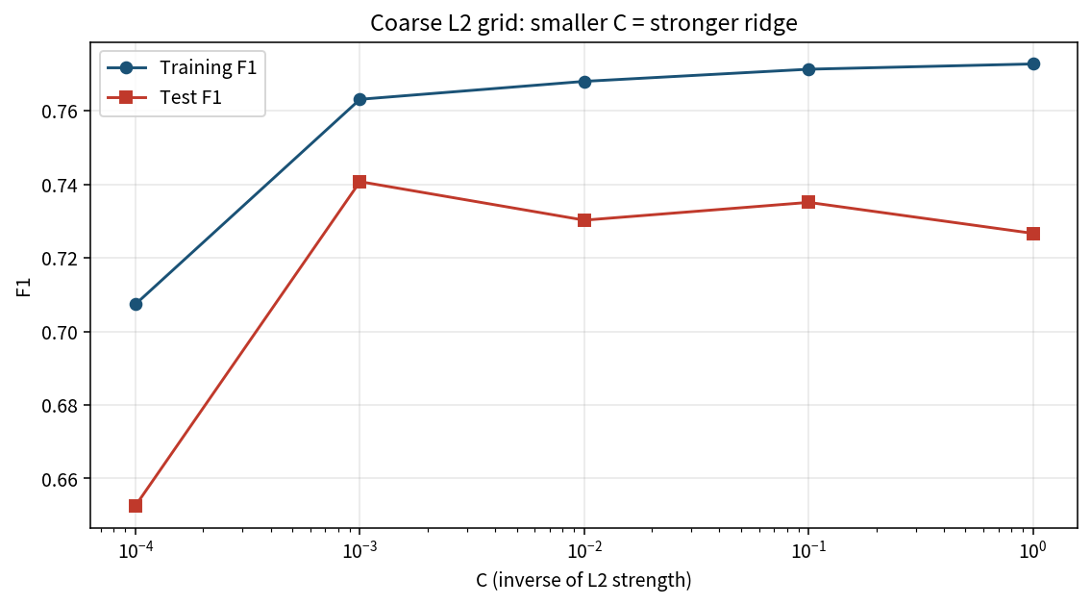

L1 vs wrappers vs filters
L1 is an embedded screen: the same model that predicts also deletes. Wrappers (SFS/SBS/RFE — see WrapFS_Obes) optimize a metric directly and cost more fits. Filters (correlation, mutual information) ignore the model class. On 11 numeric tests L1 is the cheapest honest deletion. On 18 mixed survey items a wrapper was the teaching point. Do not treat them as interchangeable in a memo.

Responsible use
- Quote F1 and AUC with the sample size and the class mix.
- Keep a frozen test fold out of the C search.
- Recalibrate after a vintage, a lab instrument change, or a new region.
- A probability of 0.51 is not a gold medal.
- Do not present this pack as tasting advice or as a purchasing algorithm.

File map
File | Role
WineReg_Practice_Skeleton.ipynb | Learner workbook
WineReg_Solution.ipynb | Worked answers + numbers
WineReg_Reusable_Template.ipynb | Drop-in for the next binary card
WineReg.py | Script form of the core path
WineReg_Cheatsheet.docx | One-screen syntax
WineReg_Project_Memo.docx | Four-audience wording
WineReg_1Page_Summary_Report.docx | One-pager
data/wine_quality.csv | UCI red, binary quality
wine_reg_*.png | Flow, coefs, C-curve, L1, ROC, sim

